 

Web Applications, A.Y. 2019/2020

Master Degree in Computer Engineering

Master Degree in ICT for Internet and Multimedia

Homework 1 – Client-side Design and Development

Submission date: 24 April 2020

|  |  |  |
| --- | --- | --- |
| **Last Name**    STEFANI  CASAGRANDE  KARAKAYA | **First Name**  CLAUDIO  NICOLA  UFUK BARAN | **Badge Number**  1244991  1242363  1215960 |

Objectives

The purpose of our project is to create a web application that allows us to order shopping online by choosing from the various supermarkets registered on the platform. The stakeholder of the website is the client but for demonstration purposes we add a supermarket manager dashboard.

Each supermarket manager can add products with relative prices and manage the orders that are placed. Each customer can choose between different supermarkets and order their shopping directly from home.

We aim to create a responsive and simple interface in order to make intuitive the user experience.

Main Functionalities

The main functionalities of the supermarket manager would be:

* add/edit products with relative information (price, photo, description)
* accept/reject customers orders
* edit supermarket profile

The main functionalities of the client are:

* add products to the shopping cart
* schedule the purchase of one or more products
* check the order status

Design Choices

For our project, we decided to use Pure CSS Framework (<https://purecss.io/>) because it is very tiny (4KB minified) so it makes the website loading speed fast also on low bandwidth devices. It is useful to create responsive layouts, and also it contains some styled layout elements such as buttons and form fields.

The website design is minimal and flat, we used ‘Archivo Black’ font for headings and ‘Montserrat’ for other elements.

According to the effects of the colors on the human brain, we think that for shopping and food purposes the best colors to use on the website are orange, yellow, and green.

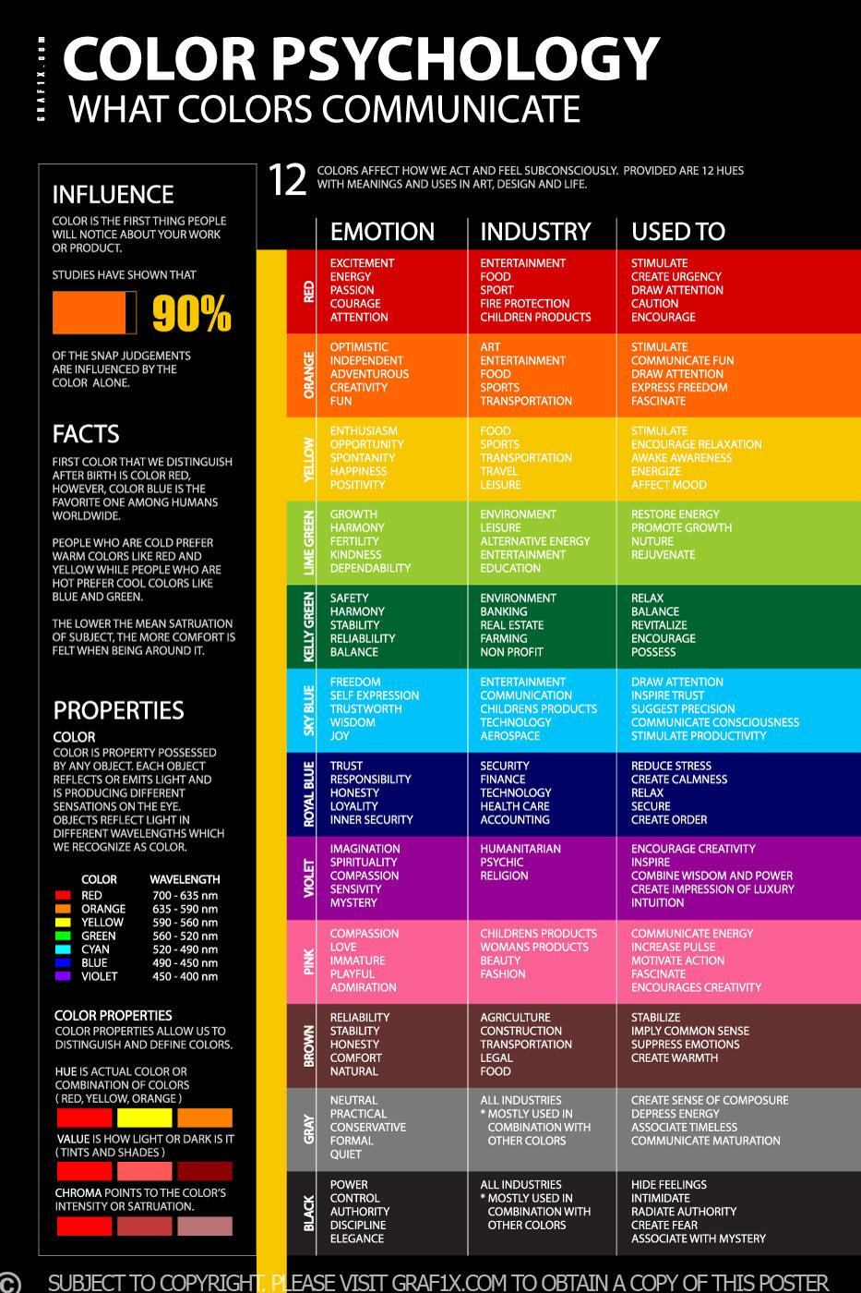

We will plan to standardize buttons and other elements styles in order to make them consistent on each page of our website.

For an easier Document Object Model Elements manipulation, manage events and animations we plan to use JQuery library.

For every HTTP request that needs authentication, we plan to use a bearer token under the HTTP authorization header, in this way:

*Authorization: Bearer_token*

Login and signup pages are public, while all other pages require authentication.

Login

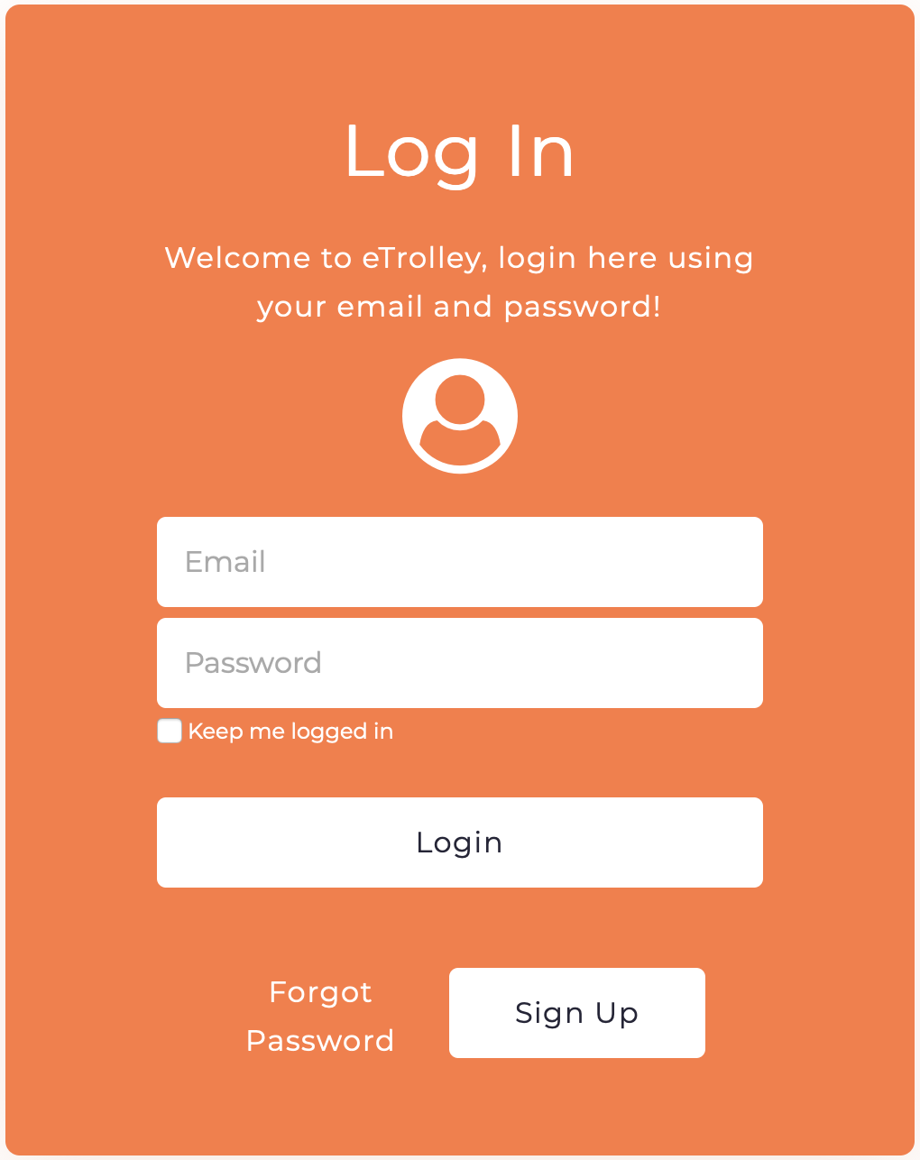

In the login page, the registered users write their credentials and send them to the server with a form in order to access the private area. The user must specify its email and password in order to log-in. There is also a “Remember me” checkbox to make the session expire time longer. A user can open the login form clicking on the Login button at the top-right. For users that do not have an account yet and want to sign up they can click on the Sign-Up button.

The forgot password button will make the user able to change the password if it’s lost.

The communication with the server is simulated using JSON format, a login request body will contain something similar to this:

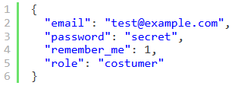

In case the login is successful, the server will respond with HTTP status code 200 and the response will contain a JSON file describing the user object plus the API token for the future requests:

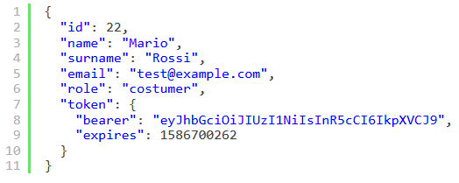

If there are errors, the server will respond with HTTP status code 401 with the explanation of the problem:

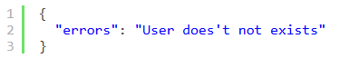

The error message will be displayed creating an error box with Javascript and appending the string as Text Node.

Sign Up

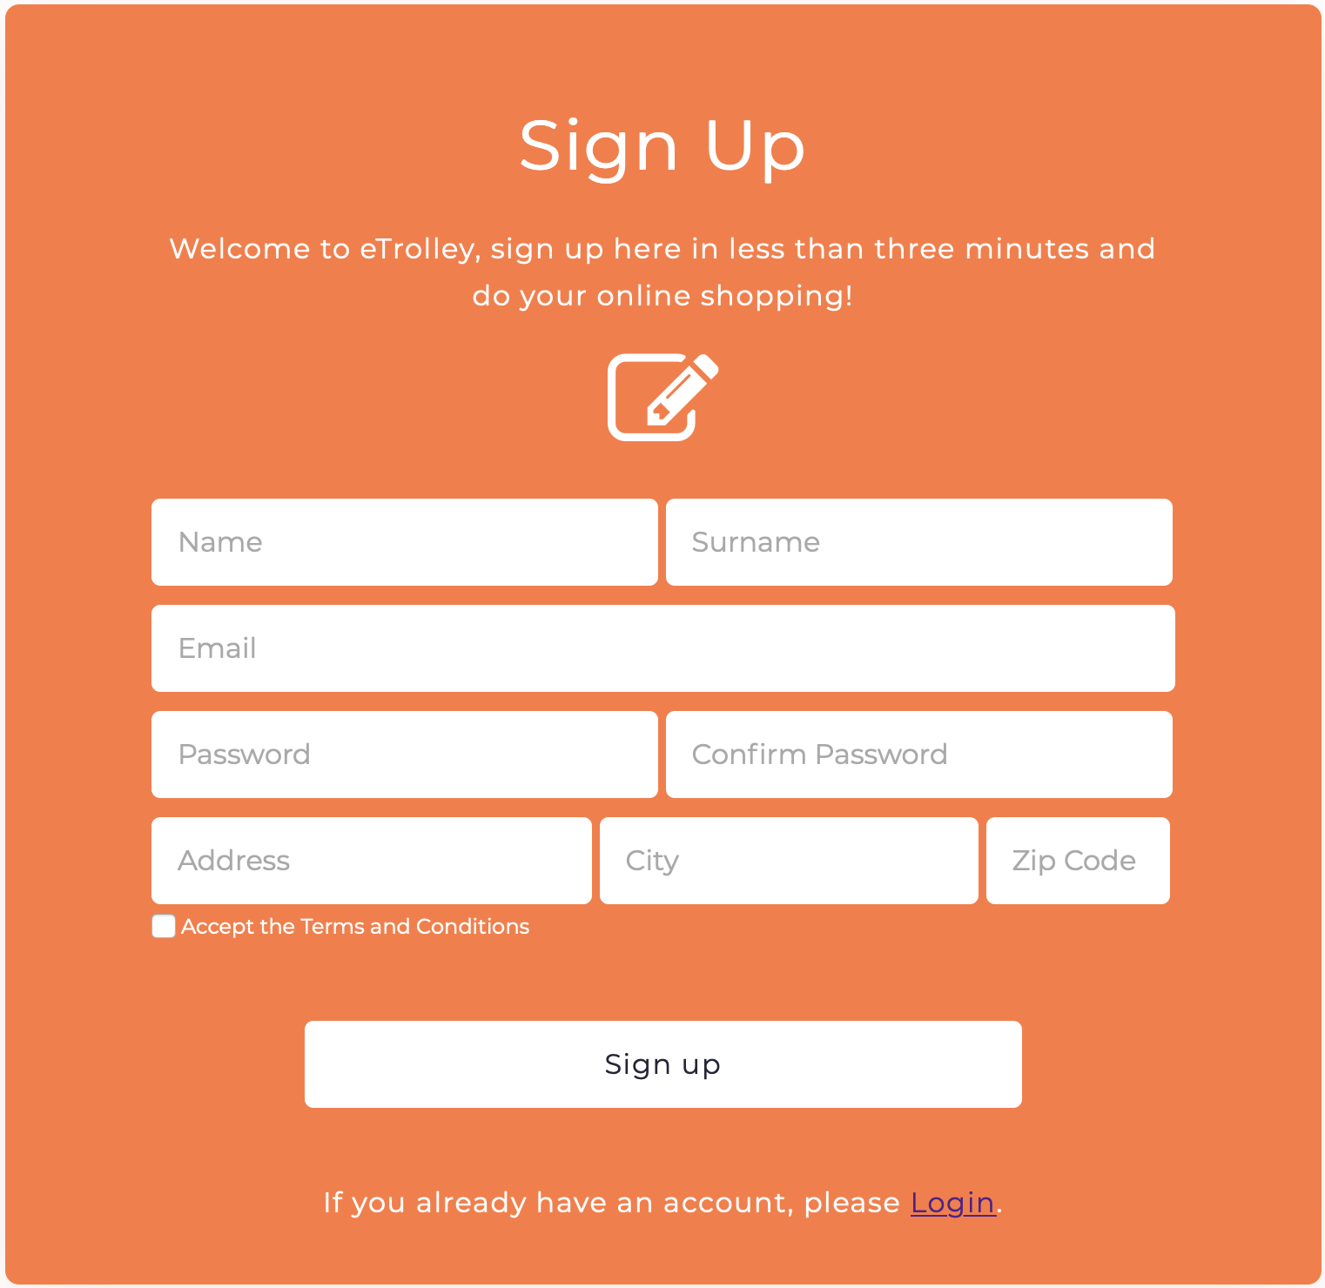

The Sign Up page presents a form where new users can register in our website. The form requires the main user information.

A new user has to insert:

* Name
* Surname
* Email: it needs to be unique in order to be able to distinguish between different users and to log in to the website.
* Password: a mild strong password of at least 8 characters long, with both lower-case and upper-case letters and numbers.
* Password confirm: must be the same as the password
* Address
* City
* Zip Code

**Post Request to create a new user and hold his/her own information:**

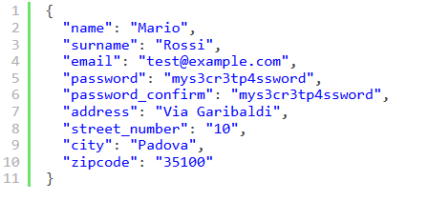

In case of errors, the server responds with HTTP Status code 422 with a JSON containing the list of the errors:

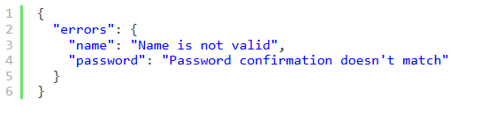

For each error, a new <span> element will be created using Javascript and will be added after the respective input and a custom CSS class will be applied on the erroneous field.

Also semantic input types such as <input type="email"> will be used as appropriate, together with validation-related attributes, for example applying “required” to fields that the user must fill.

In case of success, the server responds with HTTP status code 201 and sends the same JSON structure as login success (user object plus token info).

Dashboard (mockup) for supermarket manager

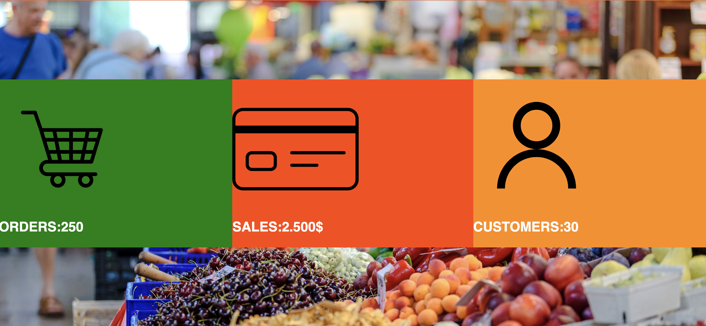

This part of the website is dedicated to supermarket managers and through the dashboard it is possible to analyze the statistics of the store. In particular they can viewed Total Order, Total Sales, and Count of Customers. We made this part only for demonstration purposes.

To show the data, a GET request to the server will be made.

Homepage

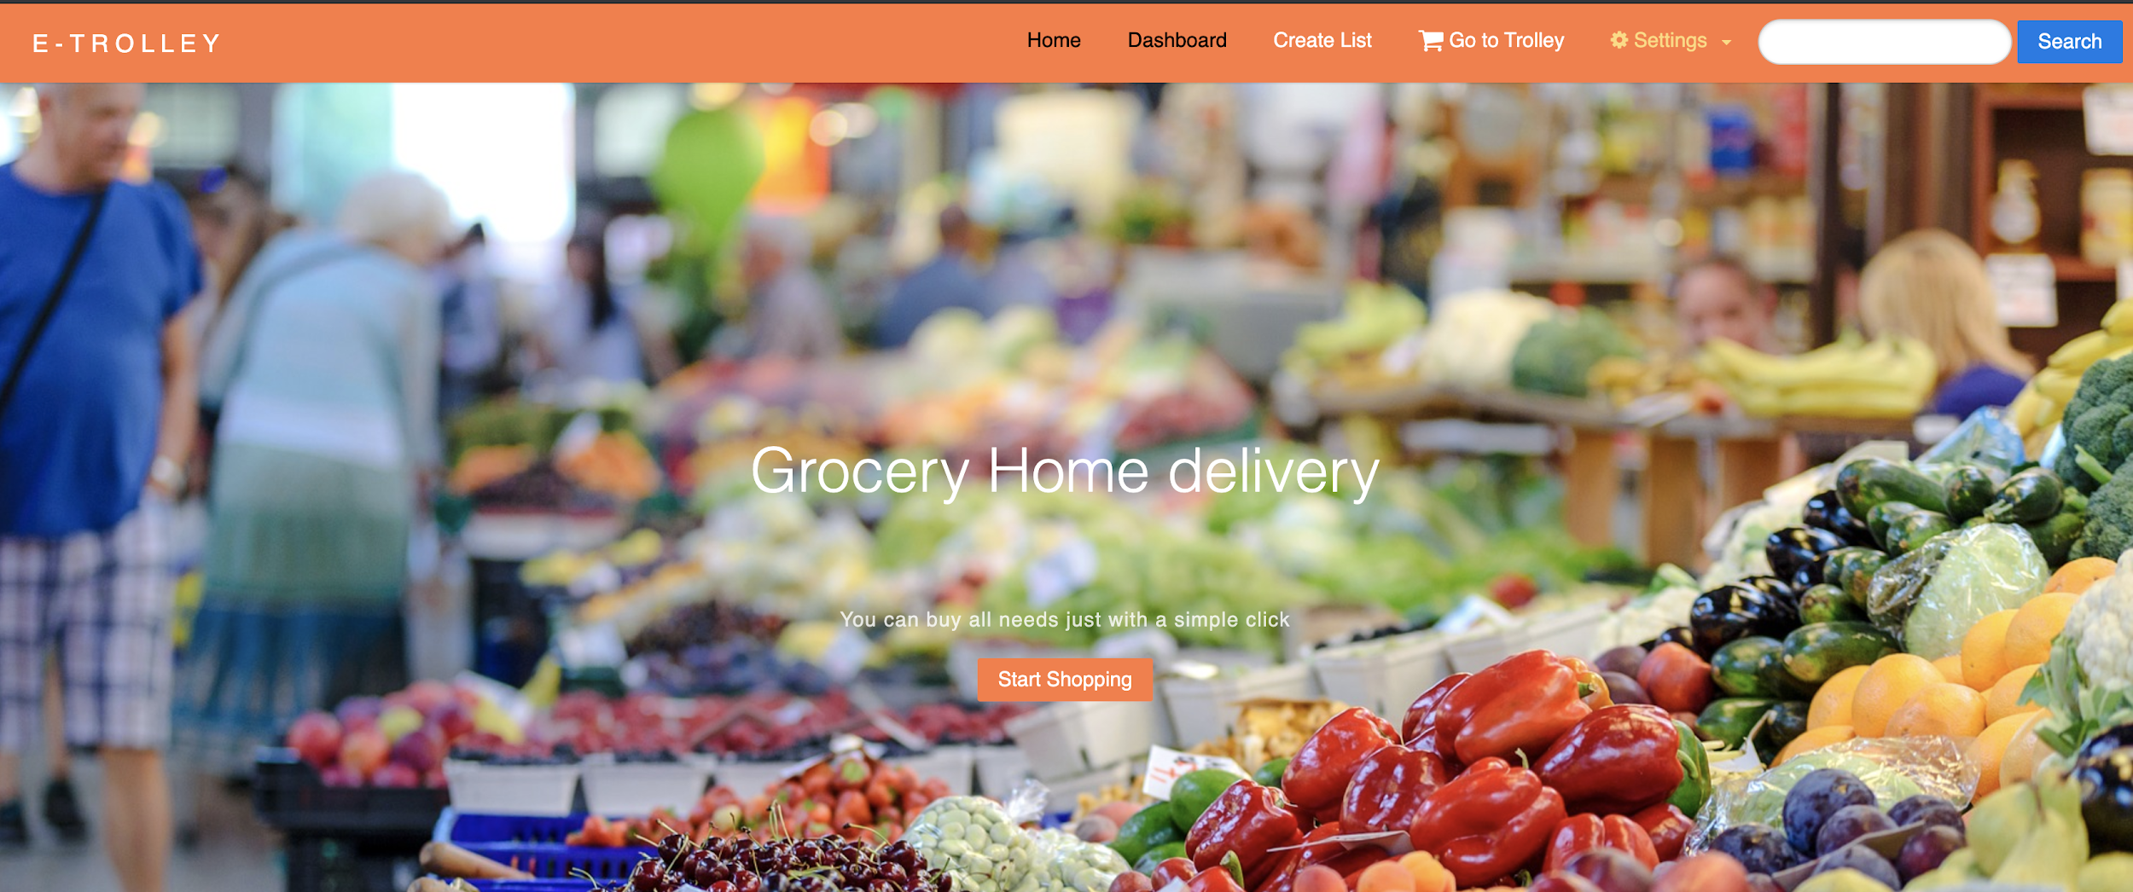

The main page after the login process. The user can create a list to write his or her own notes and it calls 1 POST request to create a list for the user.

**Create List** button is used for this task. After the creation of the list, the user can check the products which are bought. The user can see which product is missed or every need is bought.

To create a new shopping list the client sends a request containing a JSON array of products that wants to buy (free text).



The server responds with 200 OK in case of success.

**Go to Trolley** is used for confirmation and make a payment after the shopping. It calls a POST request to see all products which are bought.

Settings

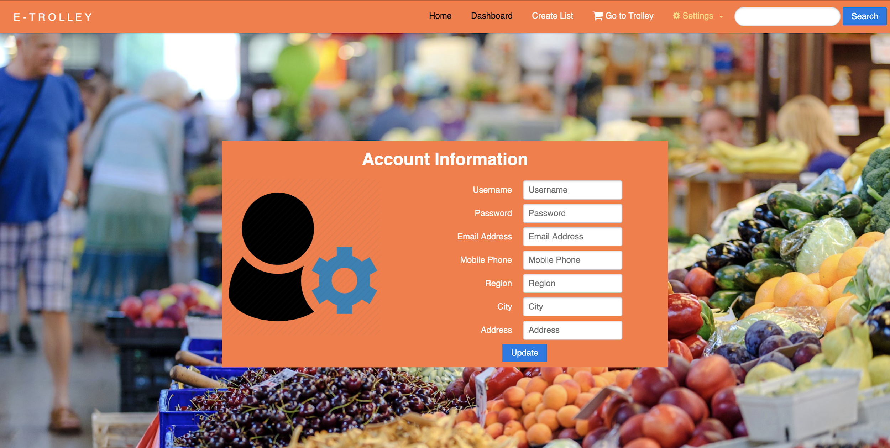

On the settings page, the user can change his own contact information and personnel preferences. When the users click “Update” button it calls 1 PUT request sending a JSON with the same structure as the signup page. In case of errors in the fields sent, the server responds with HTTP status code 422 with the same JSON file pattern as in the signup section.

In case of success, it responds with a status code 200.

This page uses the same patterns of validation of signup page.

List of Supermarkets

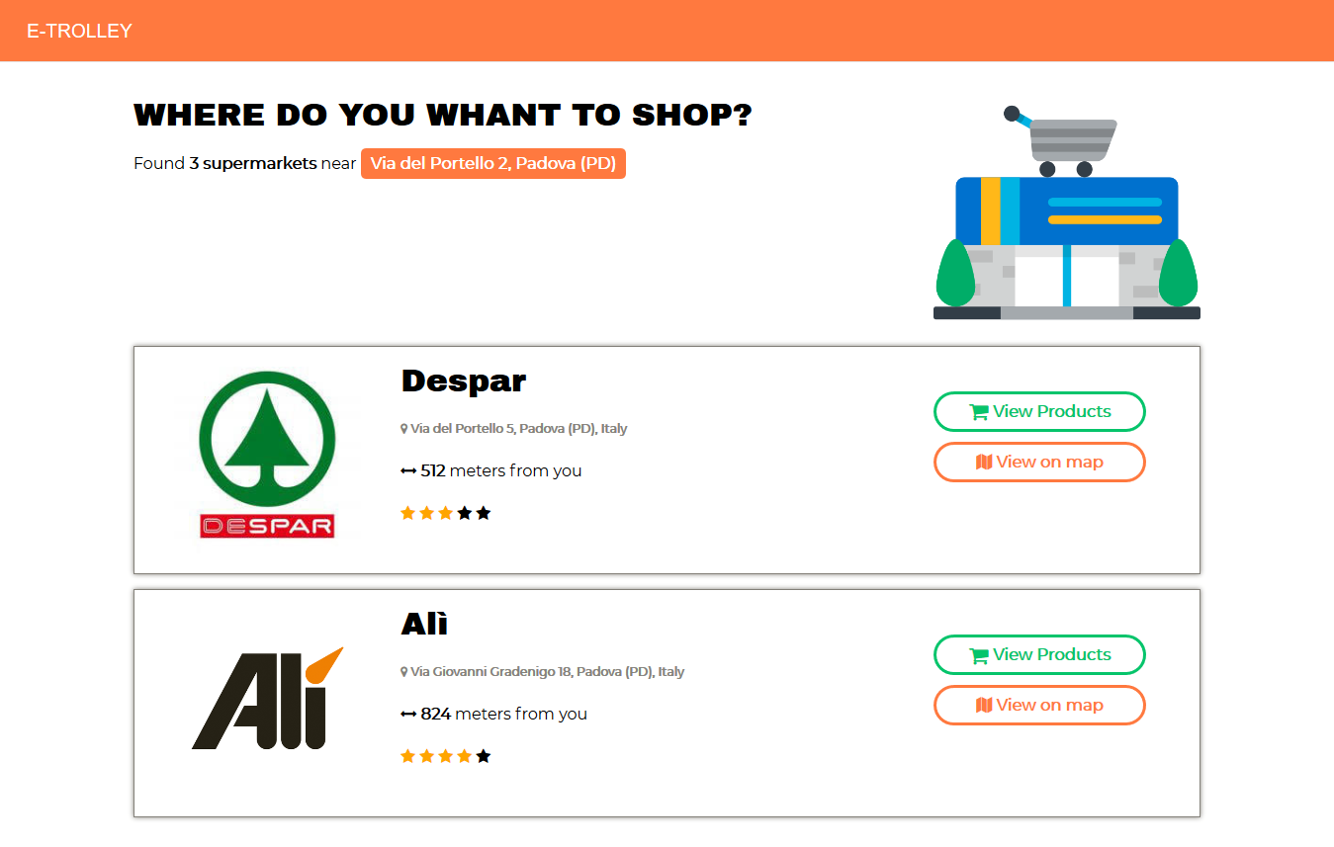

If a user wants to search a certain supermarket (from the header of the website) sends a GET request with the parameter “search” and it goes to the supermarket list page.

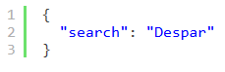

Also, when the user clicks on “start shopping” button in the homepage, it creates a list of supermarkets according to distance from the address in the database. It calls 1 Get Request to reach the list of supermarkets. The response would be:

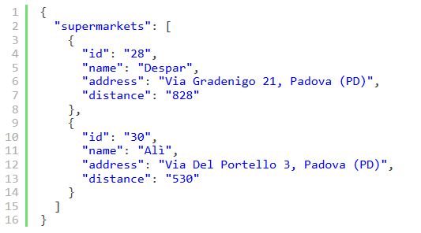

Clicking on “View on map” button, a modal window will be opened and the position of selected supermarket will be shown inside a map box. As modal plugin we used “Jquery Modal” (<https://jquerymodal.com/>) that has a simple markup and it’s easy to style.

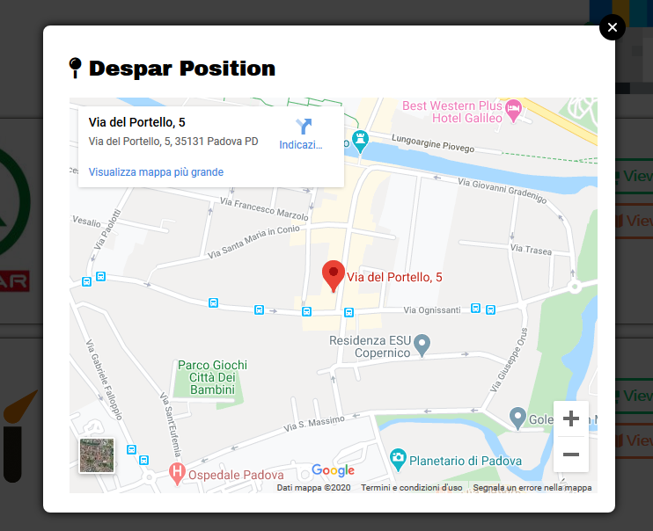

For now, we used a Google Maps iframe to embed the Map in our website.

Products Page

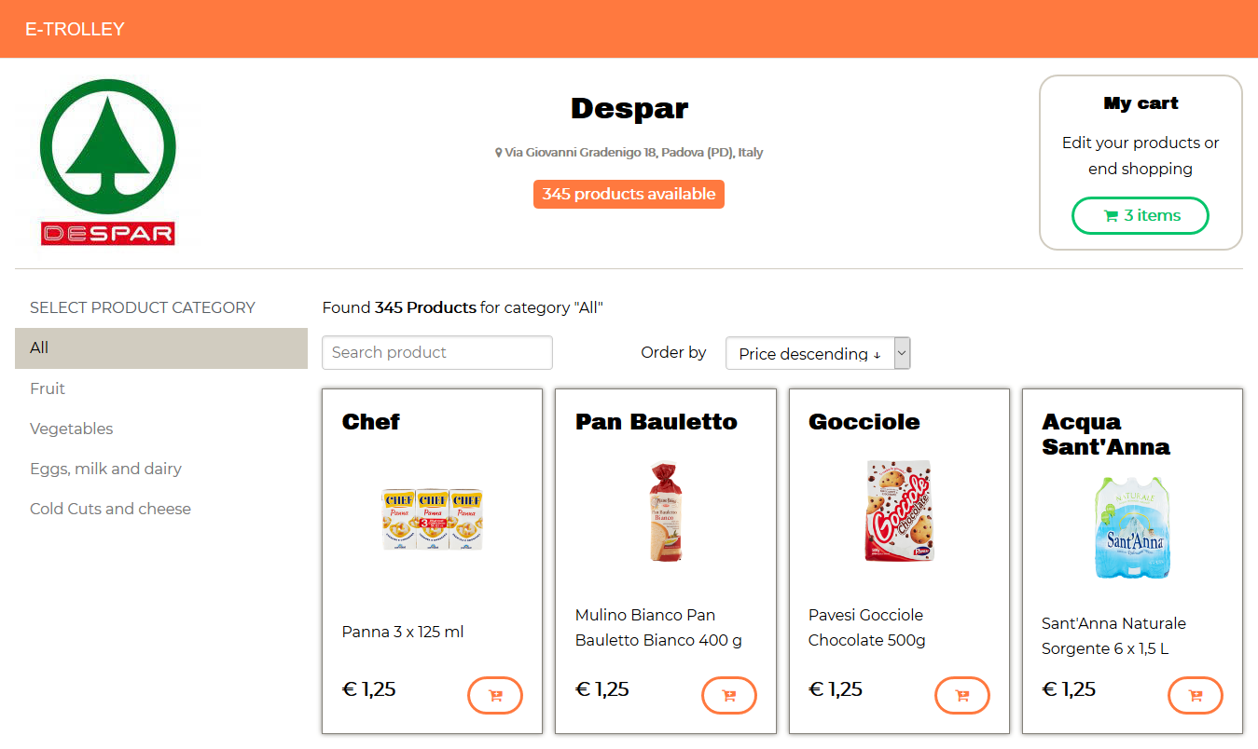

When the user selects a supermarket, it calls GET REQUEST to show information on supermarket and all products which are in the supermarket. The user can change the sort of products according to category and price.

The response of first get request to get some page data is that:

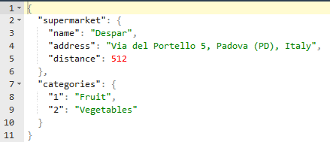

To retrieve products client sends a get request with these parameters

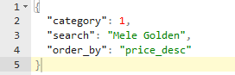

And the server responds with a JSON array of product objects.

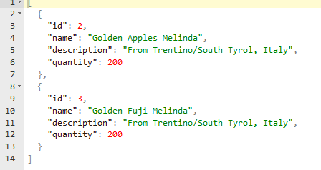

When a user clicks “cart plus” button, it will add the product to the shopping cart.

The trolley will be visible in a modal window from button in “My cart” section, and it will be possible to remove or edit product quantity and also continue to the payment (it would be a fake payment page).

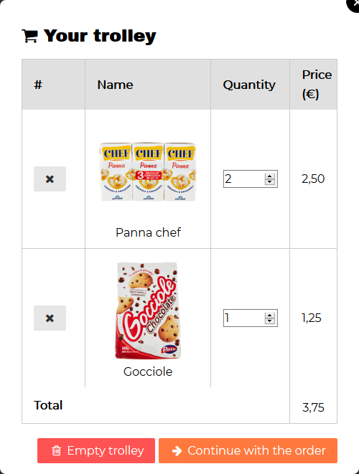

The costumer can specify the product quantity using an input type “number” and continue with the order (go to payment page) or empty the trolley using the buttons.